EXPERIMENT NO:7
DATE:

AIM
To design and represent the State Diagram for a Library Information System using UML.

OBJECTIVE
To understand the different states involved in the library management process. To represent the transitions between different states of a book.
To model the dynamic behavior of the system using a state diagram.

COMPONENTS USED
• Computer system
• UML modeling tools such as StarUML or Lucidchart
• Library Information System design

MODULES
- Book Module – Maintains book details and availability status.
- Member Module – Stores member information and membership validation.
- Issue Module – Handles issuing of books to members.
- Return Module – Updates the system when books are returned.
- Fine Module – Calculates fine when books are returned late.

WORKING PRINICIPLE
The State Diagram represents the various states of a book in the Library Information System and the transitions between these states.
Initially, the book is in the Available state, which indicates that the book is present in the library and ready for issue. When a member requests a book, the system checks whether the book is available and verifies the membership details.
If the member is valid and the book is available, the system changes the state of the book to Issued. In this state, the book is assigned to a member and cannot be issued to another user.
If the member returns the book within the specified time, the system updates the status and moves the book back to the Available state. If the book is not returned within the due date, the system moves to an Overdue state, where a fine may be applied.
After the overdue book is returned and the fine is paid if necessary, the system updates the status again and returns the book to the Available state.

ADVANTAGES
• Clearly represents the dynamic behavior of the system.
• Helps understand the lifecycle of a book in the library.
• Makes system design easier and more organized.
• Helps developers understand system transitions clearly.
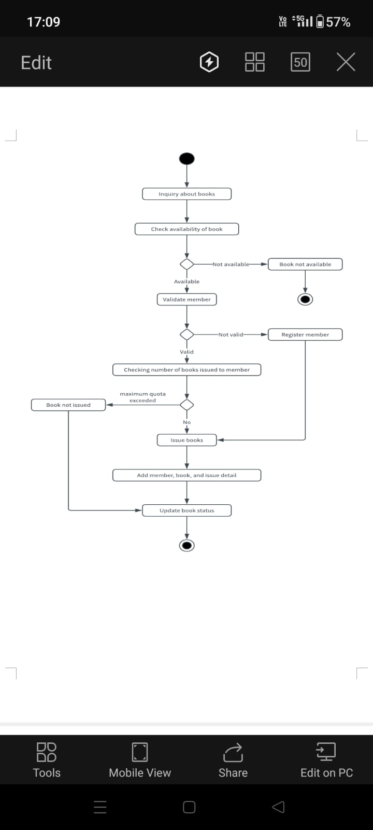

CONCLUSION
Thus, the State Diagram for the Library Information System was successfully designed and studied, which clearly shows the different states and transitions involved in managing books in the library system

